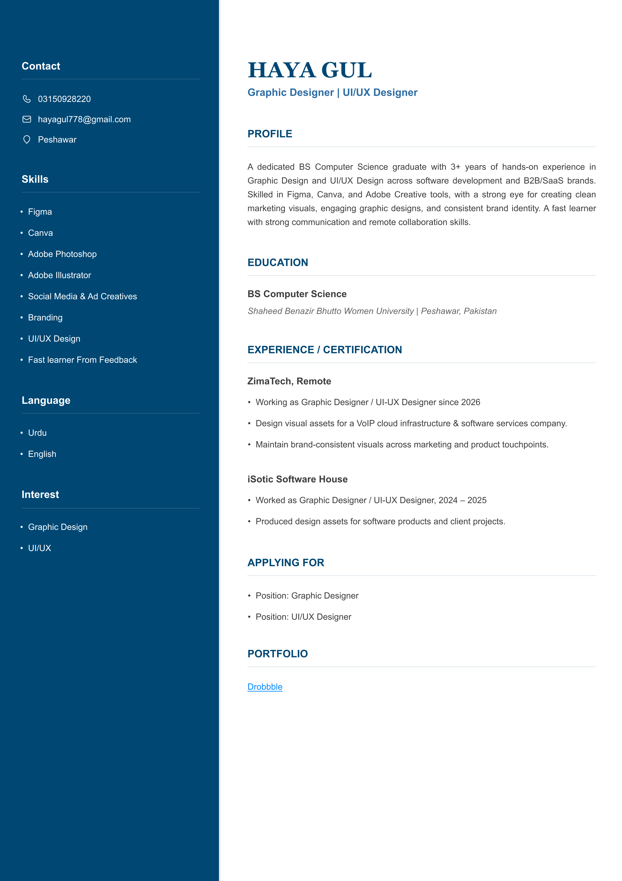
Contact
HAYA GUL
Graphic Designer | UI/UX Designer
03150928220
hayagul778@gmail.com
PROFILE
Peshawar
A dedicated BS Computer Science graduate with 3+ years of hands-on experience in
Skills
Graphic Design and UI/UX Design across software development and B2B/SaaS brands.
Skilled in Figma, Canva, and Adobe Creative tools, with a strong eye for creating clean
marketing visuals, engaging graphic designs, and consistent brand identity. A fast learner
Figma
with strong communication and remote collaboration skills.
Canva
Adobe Photoshop
EDUCATION
Adobe Illustrator
BS Computer Science
Social Media & Ad Creatives
Shaheed Benazir Bhutto Women University | Peshawar, Pakistan
Branding
UI/UX Design
EXPERIENCE / CERTIFICATION
Fast learner From Feedback
ZimaTech, Remote
Language
W orking as Graphic Designer / UI-UX Designer since 2026
Design visual assets for a VoIP cloud infrastructure & software services company.
Urdu
Maintain brand-consistent visuals across marketing and product touchpoints.
English
iSotic Software House
Interest
W orked as Graphic Designer / UI-UX Designer, 2024 – 2025
Produced design assets for software products and client pro jects.
Graphic Design
UI/UX
APPLYING FOR
Position : Graphic Designer
Position : UI/UX Designer
PORTFOLIO
Drobbble

